**ANOVA**

An Analysis of Variance (ANOVA) test is a statistical method used to compare means among three or more groups to see if at least one group mean is significantly different from the others. It's widely used in research methodology across various fields such as psychology, medicine, education, and social sciences.

Here's an overview of some common problems and considerations when using ANOVA in research methodology:

**1. Assumptions of ANOVA**

ANOVA makes several key assumptions:

* **Normality**: The data within each group should be approximately normally distributed.
* **Homogeneity of Variances (Homoscedasticity)**: The variances among the groups should be approximately equal.
* **Independence**: Observations should be independent of each other.

Violations of these assumptions can lead to incorrect conclusions. For example:

* If the normality assumption is violated, transformations of the data or non-parametric tests might be necessary.
* If homogeneity of variances is violated, a Welch ANOVA can be used as it doesn't assume equal variances.

**2. Design of the Study**

* **Randomization**: Ensuring that subjects are randomly assigned to groups helps to avoid bias.
* **Control Groups**: Including control groups helps to establish a baseline for comparison.
* **Sample Size**: Having an adequate sample size increases the power of the test and reduces the risk of Type II errors.

**3. Types of ANOVA**

* **One-Way ANOVA**: Compares means among three or more unrelated groups based on one independent variable.
* **Two-Way ANOVA**: Examines the influence of two different categorical independent variables on one continuous dependent variable and can also assess the interaction between the two factors.
* **Repeated Measures ANOVA**: Used when the same subjects are measured multiple times under different conditions.

**4. Post-Hoc Tests**

If the ANOVA indicates significant differences, post-hoc tests (e.g., Tukey's HSD, Bonferroni) are needed to determine which specific groups differ from each other. Choosing the right post-hoc test is crucial as some are more conservative than others.

**5. Effect Size**

It's important to report the effect size (e.g., eta squared, partial eta squared) along with the p-value. Effect size provides a measure of the magnitude of the differences, which is not provided by the p-value alone.

**6. Interpreting Interactions in Two-Way ANOVA**

Interpreting significant interactions in a two-way ANOVA can be challenging. It involves examining how the effect of one independent variable differs across the levels of another independent variable.

**7. Missing Data**

Handling missing data appropriately is crucial. Common methods include:

* **Listwise Deletion**: Removing all data for a subject if any single data point is missing.
* **Imputation**: Estimating missing values based on other available data.

**8. Misinterpretation of Results**

* **Overemphasis on p-values**: Solely focusing on p-values can be misleading. A comprehensive analysis includes consideration of confidence intervals and effect sizes.
* **Assuming Causality**: ANOVA can indicate association but not causality. Experimental design and further analysis are required to establish causal relationships.

**9. Software and Computation**

* Ensure the correct use of statistical software (e.g., SPSS, R, SAS). Incorrect data entry or software misuse can lead to incorrect results.

**Example of ANOVA Usage:**

Suppose a researcher wants to study the effect of different teaching methods on student performance. They randomly assign students to three groups, each experiencing a different teaching method. After a semester, they measure the students' test scores.

The researcher would:

1. Check the assumptions of ANOVA.
2. Conduct a one-way ANOVA to compare the means of the three groups.
3. If the ANOVA is significant, perform post-hoc tests to determine which groups differ.
4. Report the findings, including effect sizes and confidence intervals.

By carefully addressing these common problems and considerations, researchers can effectively use ANOVA to draw meaningful conclusions from their data.

Certainly! Let's walk through an example problem using a one-way ANOVA.

### Problem

A researcher wants to compare the effectiveness of three different diets (Diet A, Diet B, and Diet C) on weight loss. The researcher randomly assigns 15 participants to one of the three diets, with 5 participants per diet. After 8 weeks, the weight loss (in kilograms) is recorded for each participant.

The data is as follows:

* **Diet A**: 3, 4, 5, 2, 4
* **Diet B**: 6, 5, 7, 8, 6
* **Diet C**: 2, 3, 4, 1, 3

The researcher wants to know if there is a significant difference in weight loss among the three diets.

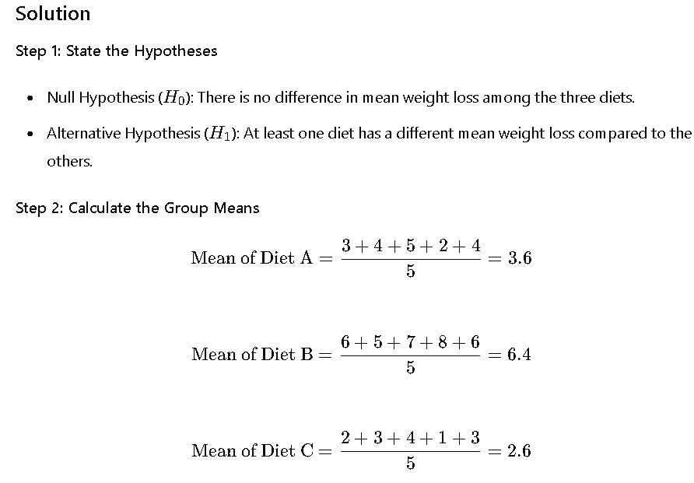

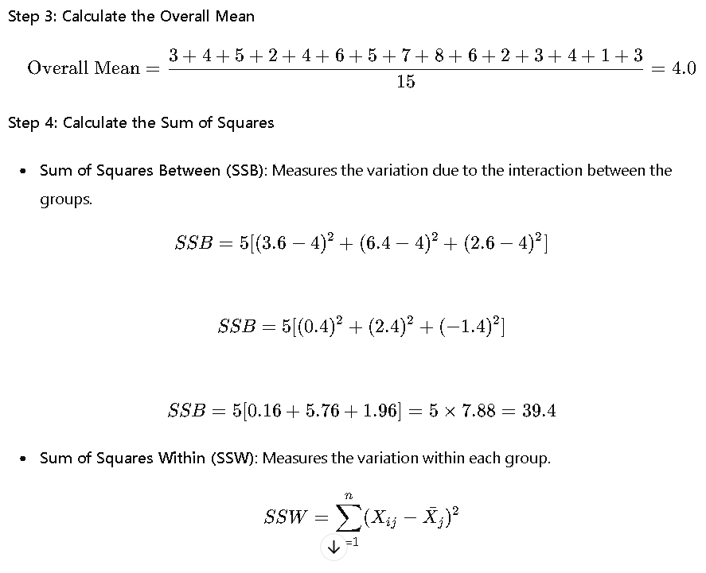

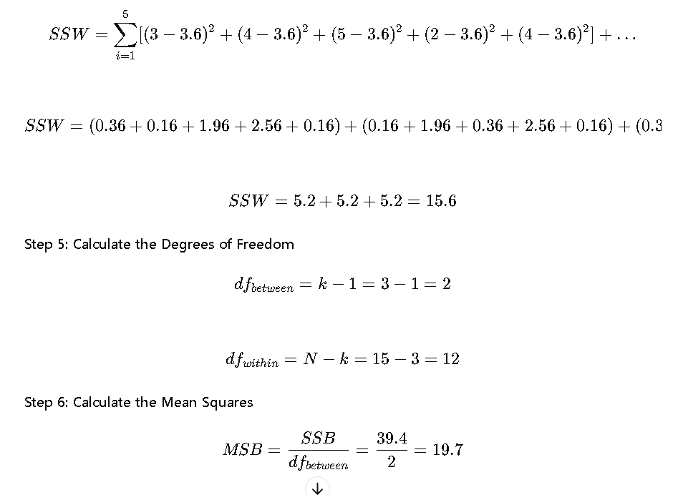

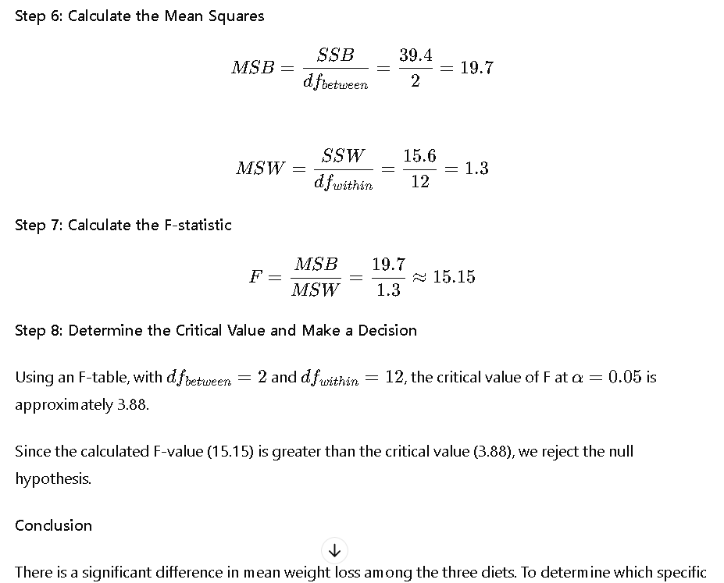

**Conclusion**

There is a significant difference in mean weight loss among the three diets. To determine which specific diets differ, post-hoc tests would be needed.

**TWO WAY ANOVA**

### Problem

A researcher wants to study the effects of two factors, Diet (A, B) and Exercise (Yes, No), on weight loss. The researcher conducts an experiment with 20 participants, randomly assigning them to one of four groups:

* Group 1: Diet A with Exercise
* Group 2: Diet A without Exercise
* Group 3: Diet B with Exercise
* Group 4: Diet B without Exercise

After 8 weeks, the weight loss (in kilograms) for each participant is recorded. The data is as follows:

* **Diet A, Exercise**: 5, 6, 4, 5, 7
* **Diet A, No Exercise**: 2, 3, 1, 2, 2
* **Diet B, Exercise**: 6, 7, 5, 6, 7
* **Diet B, No Exercise**: 3, 4, 2, 3, 3

The researcher wants to know:

1. Is there a significant effect of Diet on weight loss?
2. Is there a significant effect of Exercise on weight loss?
3. Is there a significant interaction between Diet and Exercise on weight loss?

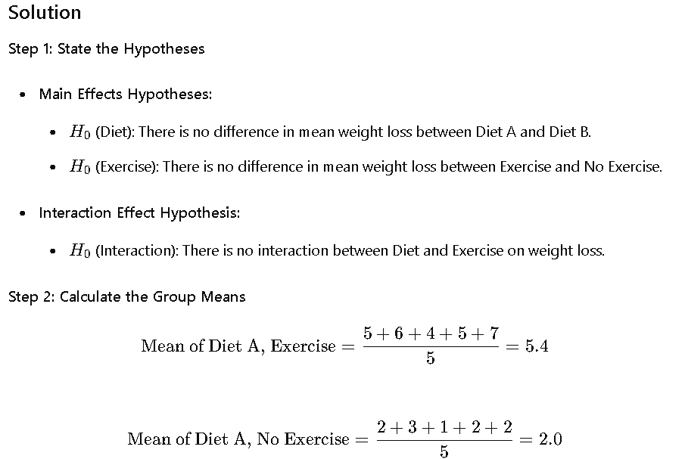

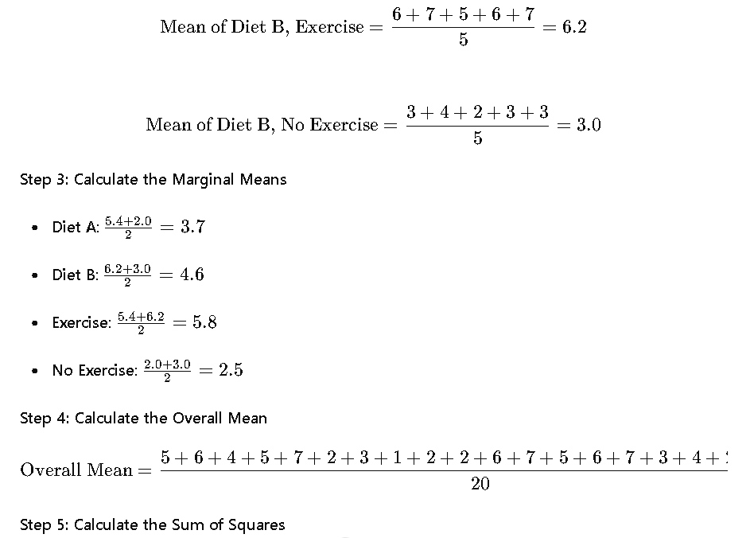

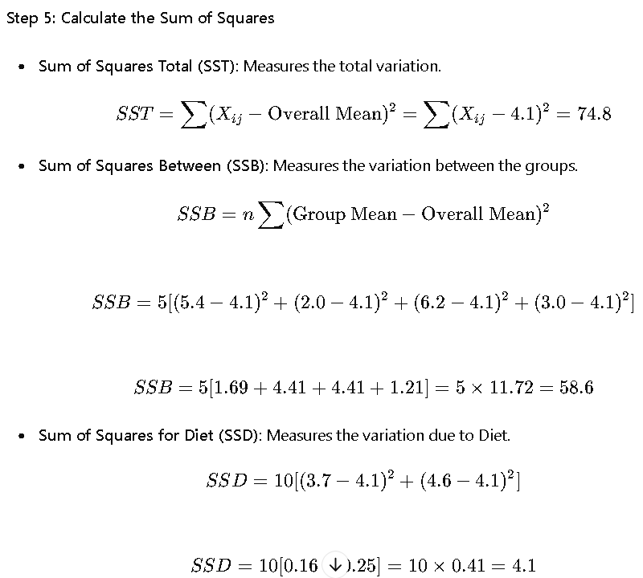

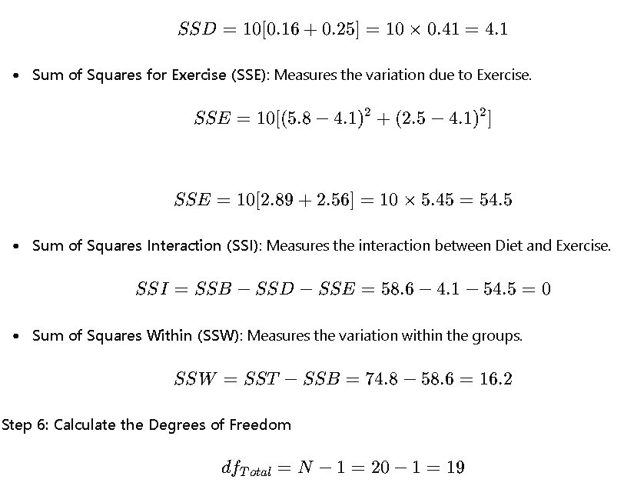

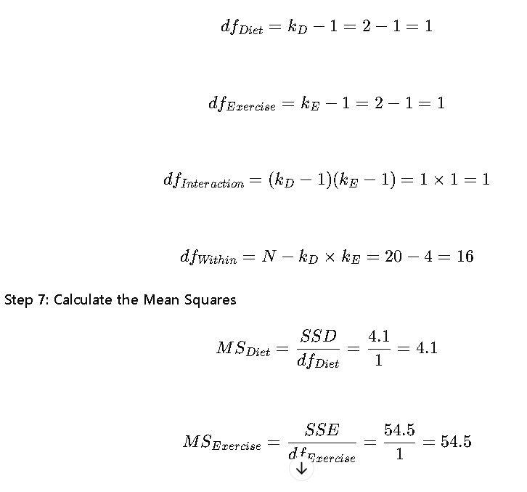

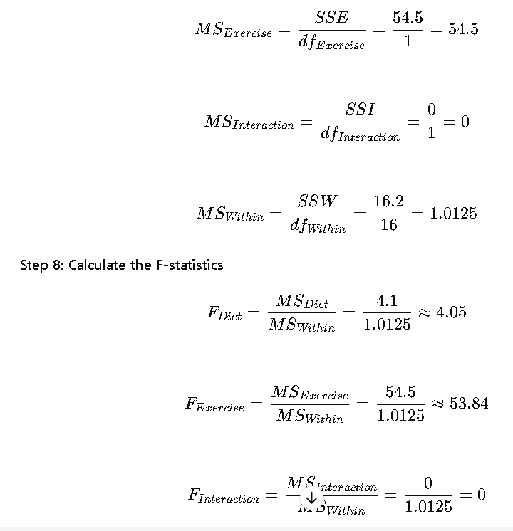

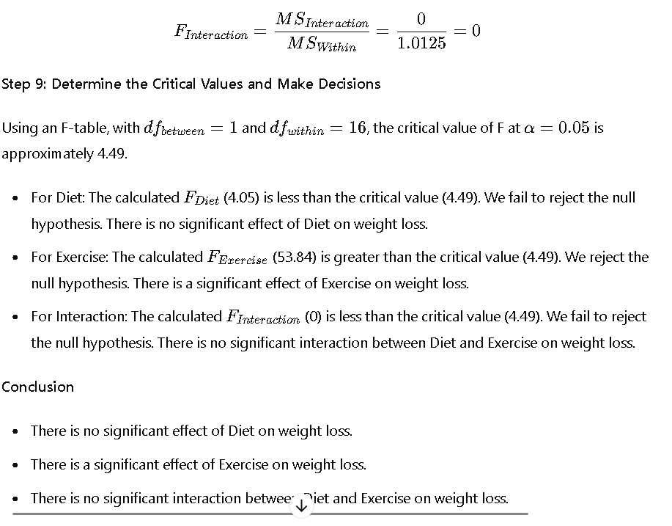

# ANOVA Test

ANOVA Test is used to analyze the differences among the means of various groups using certain estimation procedures. ANOVA means analysis of variance. ANOVA test is a statistical significance test that is used to check whether the null hypothesis can be rejected or not during hypothesis testing.

An ANOVA test can be either one-way or two-way depending upon the number of independent variables. In this article, we will learn more about an ANOVA test, the one-way ANOVA and two-way ANOVA, its formulas and see certain associated examples.

## What is ANOVA Test?

ANOVA test, in its simplest form, is used to check whether the [means](https://www.cuemath.com/data/mean/) of three or more populations are equal or not. The ANOVA test applies when there are more than two independent groups. The goal of the ANOVA test is to check for variability within the groups as well as the variability among the groups. The ANOVA test statistic is given by the [f test](https://www.cuemath.com/data/f-test/).

### ANOVA Test Definition

ANOVA test can be defined as a type of test used in [hypothesis testing](https://www.cuemath.com/data/hypothesis-testing/) to compare whether the means of two or more groups are equal or not. This test is used to check if the null hypothesis can be rejected or not depending upon the statistical significance exhibited by the parameters. The decision is made by comparing the ANOVA test statistic with the critical value.

### ANOVA Test Example

Suppose it needs to be determined if consumption of a certain type of tea will result in a mean weight loss. Let there be three groups using three types of tea - green tea, earl grey tea, and jasmine tea. Thus, to compare if there was any mean weight loss exhibited by a certain group, the ANOVA test (one way) will be used.

Suppose a survey was conducted to check if there is an interaction between income and gender with anxiety level at job interviews. To conduct such a test a two-way ANOVA will be used.

## ANOVA Formula

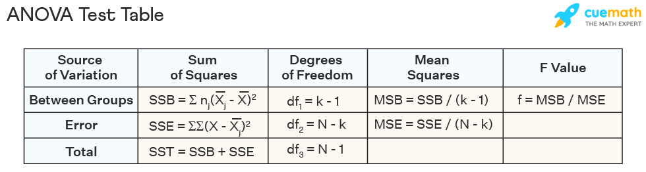

There are several components to the ANOVA formula. The best way to solve a problem on an ANOVA test is by organizing the formulas into an ANOVA table. The ANOVA formulas are given below.

Sum of squares between groups, SSB = ∑nj(¯¯¯¯¯Xj−¯¯¯¯¯X)2

. Here, ¯¯¯¯¯Xj is the mean of the jth group, ¯¯¯¯¯X is the overall mean and nj

is the sample size of the jth group.

¯¯¯¯¯X

= ¯¯¯¯¯X1+¯¯¯¯¯X2+¯¯¯¯¯X3+...+¯¯¯¯¯Xjj

Sum of squares of errors, SSE = ∑∑(X−¯¯¯¯¯Xj)2

. Here, X refers to each data point in the jth group.

Total sum of squares, SST = SSB + SSE

Degrees of freedom between groups, df1 = k - 1. Here, k denotes the number of groups.

Degrees of freedom of errors, df2 = N - k, where N denotes the total number of observations across k groups.

Total degrees of freedom, df3 = N - 1.

Mean squares between groups, MSB = SSB / (k - 1)

Mean squares of errors, MSE = SSE / (N - k)

ANOVA test statistic, f = MSB / MSE

[Critical Value](https://www.cuemath.com/data/critical-value/) at α

= F(α

, k - 1, N - k)

### ANOVA Table

The ANOVA formulas can be arranged systematically in the form of a table. This ANOVA table can be summarized as follows:

| **Source of Variation** | **Sum of Squares** | **Degrees of Freedom** | **Mean Squares** | **F Value** |
| --- | --- | --- | --- | --- |
| Between Groups | SSB = Σnj(¯¯¯¯¯Xj−¯¯¯¯¯X)2 |  |  |  |

|  |  |  |  |
| --- | --- | --- | --- |
|  | df1 = k - 1 | MSB = SSB / (k - 1) | f = MSB / MSE |
| Error | SSE = ΣΣ(X−¯¯¯¯¯Xj)2 |  |  |

|  |  |  |  |
| --- | --- | --- | --- |
|  | df2 = N - k | MSE = SSE / (N - k) |  |
| Total | SST = SSB + SSE | df3 = N - 1 |  |  |

## One Way ANOVA

The one way ANOVA test is used to determine whether there is any difference between the means of three or more groups. A one way ANOVA will have only one independent variable. The hypothesis for a one way ANOVA test can be set up as follows:

**Null Hypothesis, H0**

**:** μ1 = μ2 = μ3 = ... = μk

**Alternative Hypothesis, H1**

**:** The means are not equal

**Decision Rule:** If test statistic > critical value then reject the null hypothesis and conclude that the means of at least two groups are statistically significant.

The steps to perform the one way ANOVA test are given below:

* **Step 1:** Calculate the mean for each group.
* **Step 2:** Calculate the total mean. This is done by adding all the means and dividing it by the total number of means.
* **Step 3:** Calculate the SSB.
* **Step 4:** Calculate the between groups degrees of freedom.
* **Step 5:** Calculate the SSE.
* **Step 6:** Calculate the degrees of freedom of errors.
* **Step 7:** Determine the MSB and the MSE.
* **Step 8:** Find the f test statistic.
* **Step 9:** Using the f table for the specified level of significance, α

, find the critical value. This is given by F(α

* , df1. df2).
* **Step 10:** If f > F then reject the null hypothesis.

### Limitations of One Way ANOVA Test

The one way ANOVA is an omnibus test statistic. This implies that the test will determine whether the means of the various groups are statistically significant or not. However, it cannot distinguish the specific groups that have a statistically significant mean. Thus, to find the specific group with a different mean, a post hoc test needs to be conducted.

## Two Way ANOVA

The two way ANOVA has two independent variables. Thus, it can be thought of as an extension of a one way ANOVA where only one variable affects the dependent variable. A two way ANOVA test is used to check the main effect of each independent variable and to see if there is an interaction effect between them. To examine the main effect, each factor is considered separately as done in a one way ANOVA. Furthermore, to check the interaction effect, all factors are considered at the same time. There are certain assumptions made for a two way ANOVA test. These are given as follows:

* The samples drawn from the population must be independent.
* The population should be approximately normally distributed.
* The groups should have the same sample size.
* The [population variances](https://www.cuemath.com/data/population-variance/) are equal

Suppose in the two way ANOVA example, as mentioned above, the income groups are low, middle, high. The gender groups are female, male, and transgender. Then there will be 9 treatment groups and the three hypotheses can be set up as follows:

H01

: All income groups have equal mean anxiety.

H11

: All income groups do not have equal mean anxiety.

H02

: All gender groups have equal mean anxiety.

H12

: All gender groups do not have equal mean anxiety.

H03

: Interaction effect does not exist

H13

: Interaction effect exists.

**Related Articles:**

* [Probability and Statistics](https://www.cuemath.com/data/statistics/)
* [Data Handling](https://www.cuemath.com/data/data-handling/)
* [Data](https://www.cuemath.com/data/)
* [Z Test](https://www.cuemath.com/data/z-test/)
* [Z Score Formula](https://www.cuemath.com/z-score-formula/)

**Important Notes on ANOVA Test**

* ANOVA test is used to check whether the means of three or more groups are different or not by using estimation parameters such as the variance.
* An ANOVA table is used to summarize the results of an ANOVA test.
* There are two types of ANOVA tests - one way ANOVA and two way ANOVA
* One way ANOVA has only one independent variable while a two way ANOVA has two independent variables.

Download FREE Study Materials

ANOVA Test Worksheet

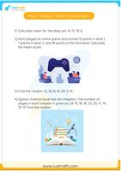

ANOVA Test Worksheet

Worksheet on Mean, Median, Mode

## Examples on ANOVA Test

1. **Example 1:** Three types of fertilizers are used on three groups of plants for 5 weeks. We want to check if there is a difference in the mean growth of each group. Using the data given below apply a one way ANOVA test at 0.05 significant level.

| **Fertilizer 1** | **Fertilizer 2** | **Fertilizer 3** |
| --- | --- | --- |
| 6 | 8 | 13 |
| 8 | 12 | 9 |
| 4 | 9 | 11 |
| 5 | 11 | 8 |
| 3 | 6 | 7 |
| 4 | 8 | 12 |

1. **Solution:**
2. H0

: μ1 = μ2 = μ3

H1

: The means are not equal

| **Fertilizer 1** | **Fertilizer 2** | **Fertilizer 3** |
| --- | --- | --- |
| 6 | 8 | 13 |
| 8 | 12 | 9 |
| 4 | 9 | 11 |
| 5 | 11 | 8 |
| 3 | 6 | 7 |
| 4 | 8 | 12 |
| ¯¯¯¯¯X1 |  |  |

|  |  |
| --- | --- |
| = 5 | ¯¯¯¯¯X1 |

|  |  |
| --- | --- |
| = 9 | ¯¯¯¯¯X1 |

|  |
| --- |
| = 10 |

Total mean, ¯¯¯¯¯X

= 8

n1

= n2 = n3

= 6, k = 3

SSB = 6(5 - 8)2 + 6(9 - 8)2 + 6(10 - 8)2

= 84

df1 = k - 1 = 2

| **Fertilizer 1** | **(X - 5)2** | **Fertilizer 2** | **(X - 9)2** | **Fertilizer 3** | **(X - 10)2** |
| --- | --- | --- | --- | --- | --- |
| 6 | 1 | 8 | 1 | 13 | 9 |
| 8 | 9 | 12 | 9 | 9 | 1 |
| 4 | 1 | 9 | 0 | 11 | 1 |
| 5 | 0 | 11 | 4 | 8 | 4 |
| 3 | 4 | 6 | 9 | 7 | 9 |
| 4 | 1 | 8 | 1 | 12 | 4 |
| ¯¯¯¯¯X1 |  |  |  |  |  |

|  |  |  |
| --- | --- | --- |
| = 5 | Total = 16 | ¯¯¯¯¯X1 |

|  |  |  |
| --- | --- | --- |
| = 9 | Total = 24 | ¯¯¯¯¯X1 |

|  |  |
| --- | --- |
| = 10 | Total = 28 |

SSE = 16 + 24 + 28 = 68

N = 18

df2 = N - k = 18 - 3 = 15

MSB = SSB / df1 = 84 / 2 = 42

MSE = SSE / df2 = 68 / 15 = 4.53

ANOVA test statistic, f = MSB / MSE = 42 / 4.53 = 9.33

Using the f table at α

• = 0.05 the critical value is given as F(0.05, 2, 15) = 3.68

As f > F, thus, the null hypothesis is rejected and it can be concluded that there is a difference in the mean growth of the plants.

**Answer:** Reject the null hypothesis

• **Example 2:** A trial was run to check the effects of different diets. Positive numbers indicate weight loss and negative numbers indicate weight gain. Check if there is an average difference in the weight of people following different diets using an ANOVA Table.

| **Low Fat** | **Low Calorie** | **Low Protein** | **Low Carbohydrate** |
| --- | --- | --- | --- |
| 8 | 2 | 3 | 2 |
| 9 | 4 | 5 | 2 |
| 6 | 3 | 4 | -1 |
| 7 | 5 | 2 | 0 |
| 3 | 1 | 3 | 3 |

**Solution:**

H0

: μ1 = μ2 = μ3 = μ4

H1

: The means are not equal

| **Low Fat** | **(X - 6.6)2** | **Low Calorie** | **(X - 3)2** | **Low Protein** | **(X - 3.4)2** | **Low Carbohydrate** | **(X - 1.2)2** |
| --- | --- | --- | --- | --- | --- | --- | --- |
| 8 | 2 | 2 | 1 | 3 | 0.2 | 2 | 0.6 |
| 9 | 5.8 | 4 | 1 | 5 | 2.6 | 2 | 0.6 |
| 6 | 0.4 | 3 | 0 | 4 | 0.4 | -1 | 4.8 |
| 7 | 0.2 | 5 | 4 | 2 | 2 | 0 | 1.4 |
| 3 | 13 | 1 | 4 | 3 | 0.2 | 3 | 3.2 |
| ¯¯¯¯¯X1 |  |  |  |  |  |  |  |

|  |  |  |
| --- | --- | --- |
| = 6.6 | Total = 21.4 | ¯¯¯¯¯X2 |

|  |  |  |
| --- | --- | --- |
| = 3 | Total = 10 | ¯¯¯¯¯X3 |

|  |  |  |
| --- | --- | --- |
| = 3.4 | Total = 5.4 | ¯¯¯¯¯X4 |

|  |  |
| --- | --- |
| = 1.2 | Total = 10.6 |

Total mean, ¯¯¯¯¯X

= 3.6

n1

= n2 = n3 = n4

= 5, k = 4

SSB = n1(¯¯¯¯¯X1−¯¯¯¯¯X)2

+ n2(¯¯¯¯¯X2−¯¯¯¯¯X)2 +& n3(¯¯¯¯¯X3−¯¯¯¯¯X)2 +n4(¯¯¯¯¯X4−¯¯¯¯¯X)2

= 75.8

SSE = 21.4 + 10 + 5.4 + 10.6 = 47.4

The ANOVA Table can be constructed as follows:

| **Source of Variation** | **Sum of Squares** | **Degrees of Freedom** | **Mean Squares** | **F Value** |
| --- | --- | --- | --- | --- |
| Between Groups | SSB = Σnj(¯¯¯¯¯Xj−3.6)2 |  |  |  |

|  |  |  |  |
| --- | --- | --- | --- |
| = 75.8 | df1 = k - 1 = 4 - 1 = 3 | MSB = SSB / (k - 1) = 25.3 | f = MSB / MSE = 8.43 |
| Error | SSE = ΣΣ(X−¯¯¯¯¯Xj)2 |  |  |

|  |  |  |  |
| --- | --- | --- | --- |
| = 47.4 | df2 = N - k = 20 - 4 = 16 | MSE = SSE / (N - k) = 3 |  |
| Total | SST = SSB + SSE = 123.2 | df3 = N - 1 = 19 |  |  |

As no significance level is specified, α

• = 0.05 is chosen.

F(0.05, 3, 16) = 3.24

As 8.43 > 3.24, thus, the null hypothesis is rejected and it can be concluded that there is a mean weight loss in the diets.

**Answer:** Reject the null hypothesis

• **Example 3:** Determine if there is a difference in the mean daily calcium intake for people with normal bone density, osteopenia, and osteoporosis at a 0.05 alpha level. The data was recorded as follows:

| **Normal Density** | **Osteopenia** | **Osteoporosis** |
| --- | --- | --- |
| 1200 | 1000 | 890 |
| 1000 | 1100 | 650 |
| 980 | 700 | 1100 |
| 900 | 800 | 900 |
| 750 | 500 | 400 |
| 800 | 700 | 350 |

**Solution:**

Using the ANOVA test the hypothesis is set up as follows:

H0

: μ1 = μ2 = μ3

H1

: The means are not equal

| **Normal Density** | **(X - 938.3)2** | **Osteopenia** | **(X - 800)2** | **Osteoporosis** | **(X - 715)2** |
| --- | --- | --- | --- | --- | --- |
| 1200 | 68,486.9 | 1000 | 40,000 | 890 | 30,625 |
| 1000 | 3,806.9 | 1100 | 90,000 | 650 | 4,225 |
| 980 | 1,738.9 | 700 | 10,000 | 1100 | 148,225 |
| 900 | 1,466.9 | 800 | 0 | 900 | 34,225 |
| 750 | 35,456.9 | 500 | 90,000 | 400 | 99,225 |
| 800 | 19,126.9 | 700 | 10,000 | 350 | 133,225 |
| ¯¯¯¯¯X1 |  |  |  |  |  |

|  |  |  |
| --- | --- | --- |
| = 938.3 | Total = 130,083.3 | ¯¯¯¯¯X2 |

|  |  |  |
| --- | --- | --- |
| = 800 | Total = 240,000 | ¯¯¯¯¯X3 |

|  |  |
| --- | --- |
| = 715 | Total = 449,750 |

Total mean, ¯¯¯¯¯X

= 817.8

n1

= n2 = n3

= 6, k = 3

SSB = n1(¯¯¯¯¯X1−¯¯¯¯¯X)2

+ n2(¯¯¯¯¯X2−¯¯¯¯¯X)2 + n3(¯¯¯¯¯X3−¯¯¯¯¯X)2

= 152,477.7

SSE = 130,083.3 + 240,000 + 449,750 = 819,833.3

The ANOVA Table can be constructed as follows:

| **Source of Variation** | **Sum of Squares** | **Degrees of Freedom** | **Mean Squares** | **F Value** |
| --- | --- | --- | --- | --- |
| Between Groups | SSB = Σnj(¯¯¯¯¯Xj−817.8)2 |  |  |  |

|  |  |  |  |
| --- | --- | --- | --- |
| = 152,477.7 | df1 = k - 1 = 3 - 1 = 2 | MSB = SSB / (k - 1) = 76,238.6 | f = MSB / MSE = 1.395 |
| Error | SSE = ΣΣ(X−¯¯¯¯¯Xj)2 |  |  |

|  |  |  |  |
| --- | --- | --- | --- |
| = 819,833.3 | df2 = N - k = 18 - 3 = 15 | MSE = SSE / (N - k) = 54,655.5 |  |
| Total | SST = SSB + SSE = 972,311 | df3 = N - 1 = 17 |  |  |

Using the F table the critical value is F(0.05, 2, 15) = 3.68

As 1.395 < 3.68, the null hypothesis cannot be rejected and it is concluded that there is not enough evidence to prove that the mean daily calcium intake of the three groups is different.

**Answer:** Do not reject the null hypothesis